ESTIMATION OF BUSINESS EXPENSES

1. **INTRODUCTION**

Business expenses refer to the costs incurred by a company in its day-to-day operations to generate revenue, maintain its operations, and support its growth. These expenses can encompass a wide range of items and are an integral part of a company's financial management and reporting. Properly tracking and managing business expenses is essential for financial stability, profitability, and regulatory compliances.

**1.1 OVERVIEW**

Expense estimation allows a business to anticipate financial risks and uncertainties, which can then be addressed through risk mitigation strategies. This proactive approach helps in avoiding financial crises.

* 1. **PURPOSE**

Expenses are a fundamental component of financial planning. They are used to create budgets, set financial goals, and allocate resources effectively. Without a clear understanding of expenses, a business cannot make informed financial decisions.

1. **PROBLEM STATEMENT & DESING THINKING**

Understand the pain points and challenges that businesses face when it comes to managing expenses. Conduct interviews, surveys, and observations to gather insights from businesses of various sizes and industries.

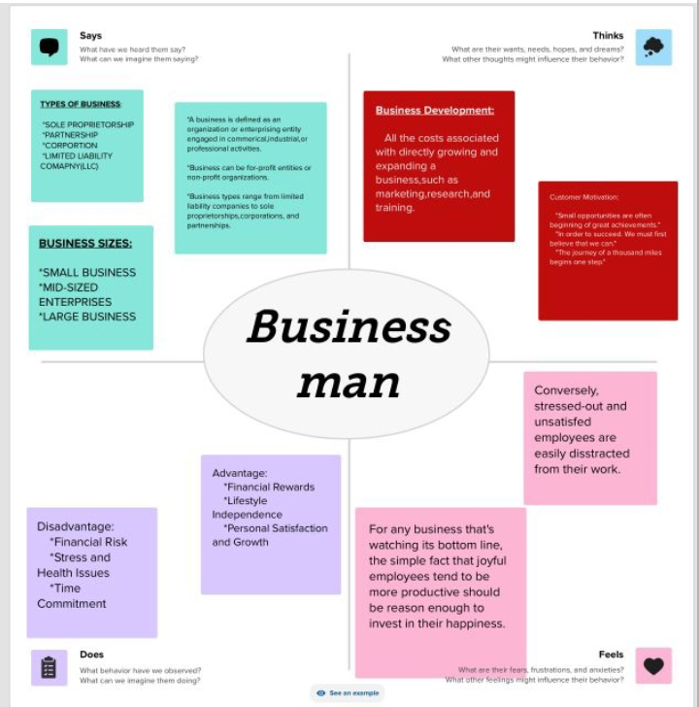**2.2 EMPATHY MAP**

**2.3 IDEATION & BRAINSTROMING**

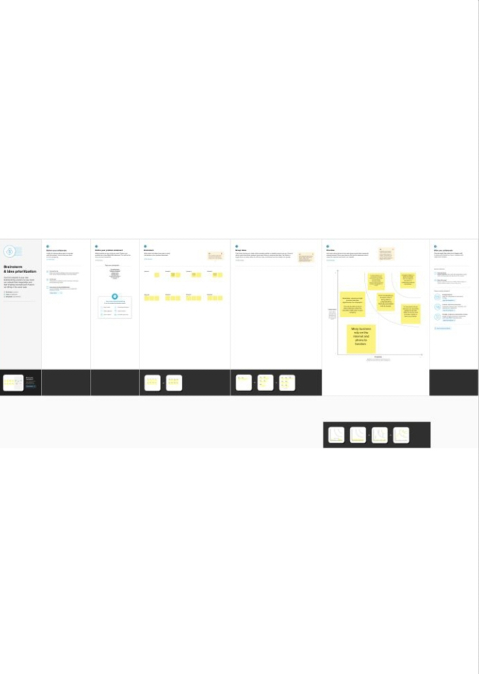

1. **RESULT**

**3.1 ANNUAL PAYROLL**

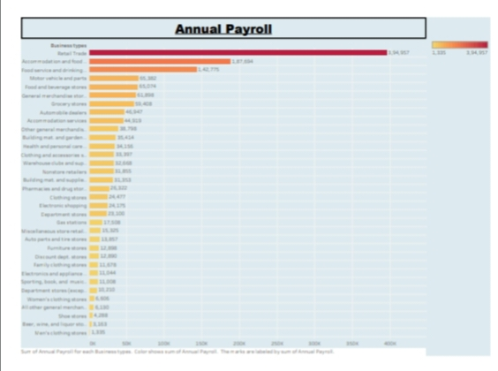

**3.1.2 ADVETISEMENT COST**

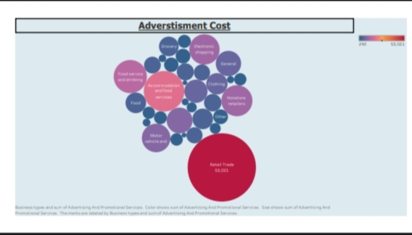

**3.1.3 CONTRACT LABOUR VS EMPLOYEE COST**

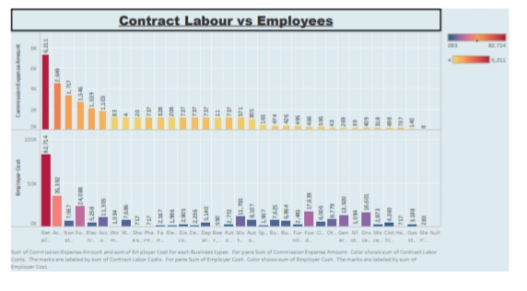

**3.1.4 EMPLOYER COST (INSURANCE VS PENSION)**

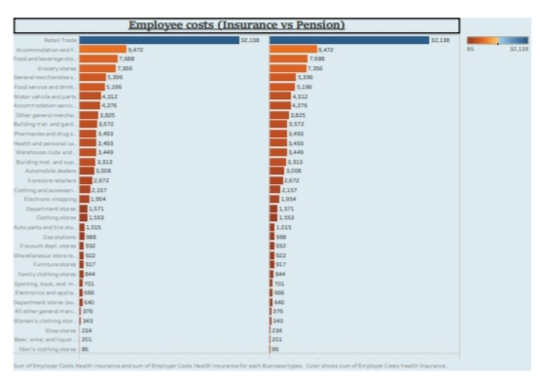

3.1.5 EQUIPMENT COST

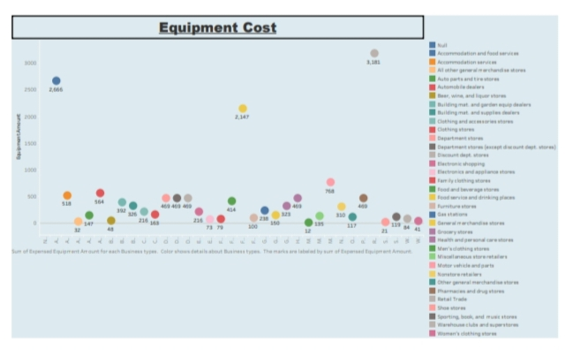

**3.1.6 EXPENSES YOY**

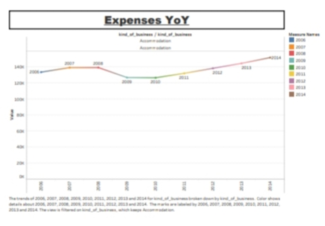

**3.1.7 FUEL**

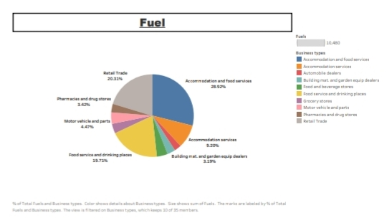

**3.1.8 POWER EXPENDITURE**

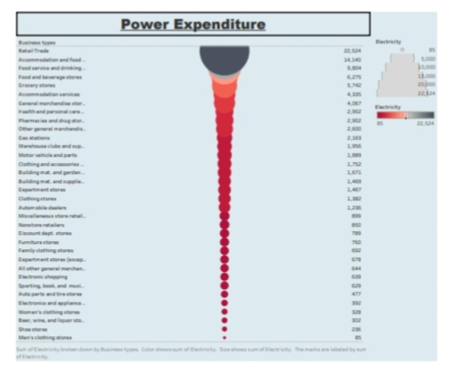

**3.1.9 MAINTENANCE BUILDINGS**

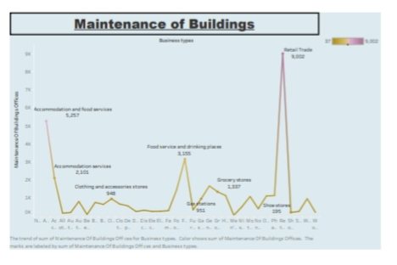

**3.1.10. RENTAL PAYMENT FOR MECHINARY**

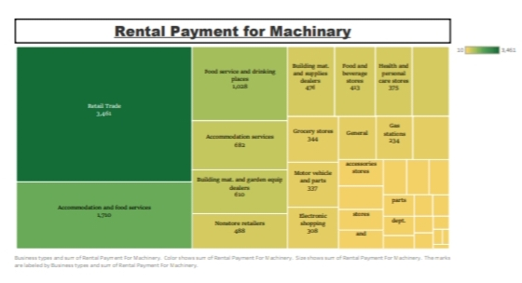

**3.1.11. TAXES & LICENSES**

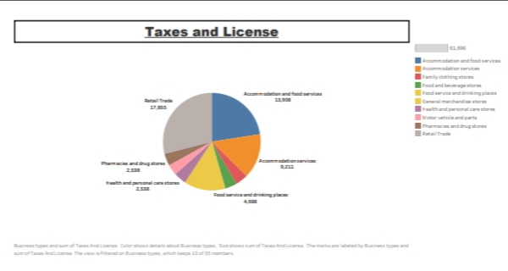

**3.1.12. TRANSPORTATION**

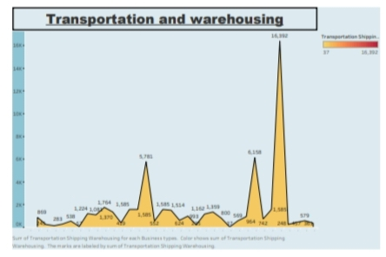

**DASHBOARD 1**

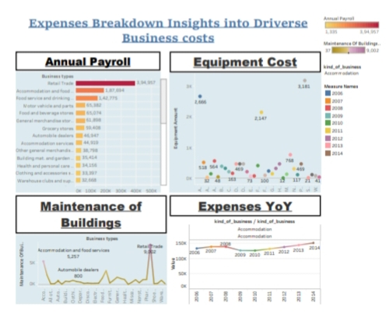

**DASBOARD 2**

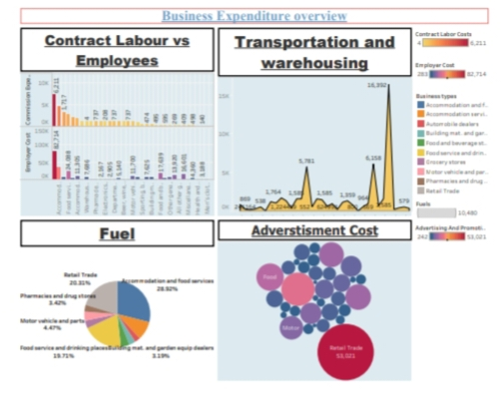

**DASHBOARD 3**

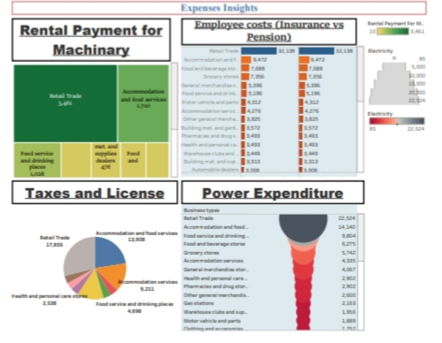

**STORY 1**

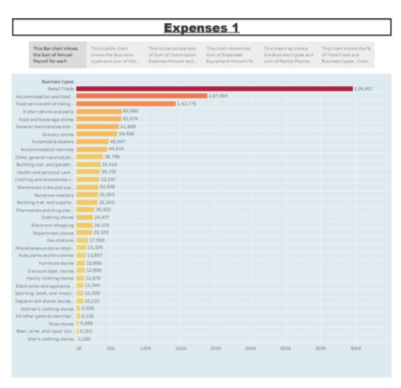

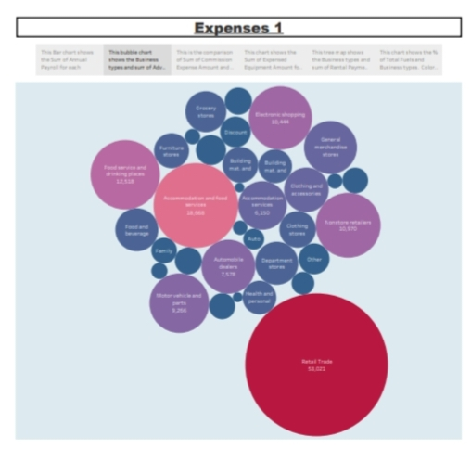

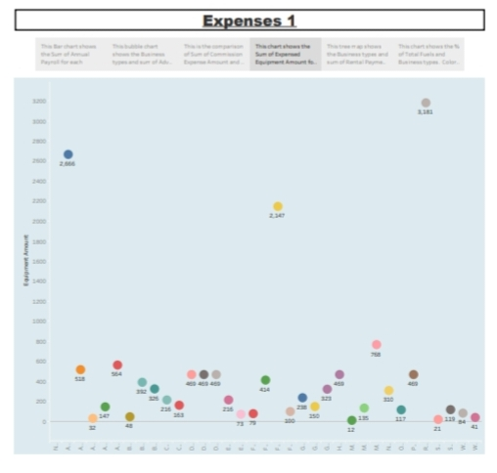

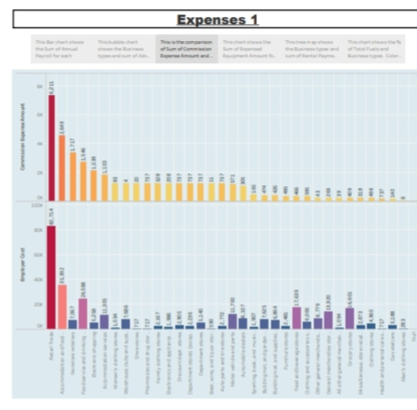

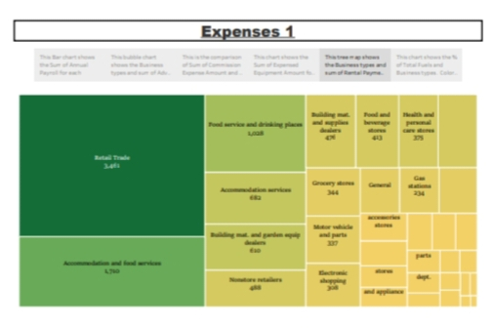

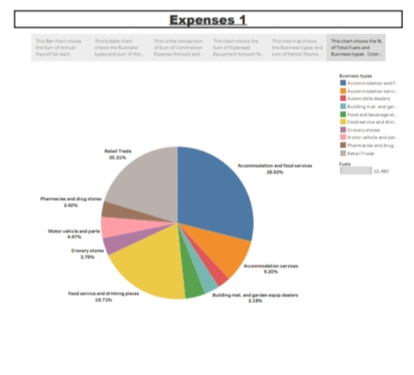

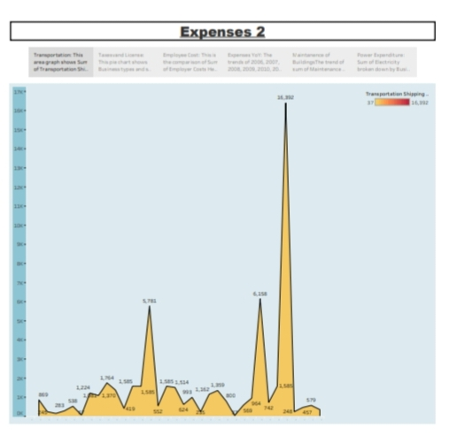

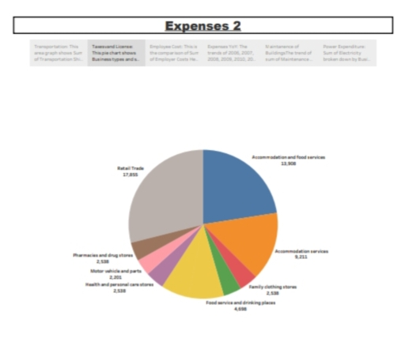

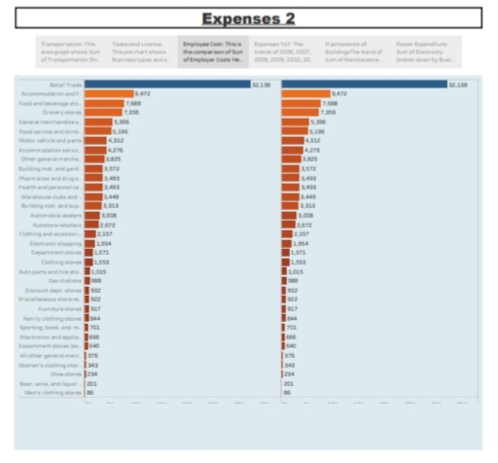

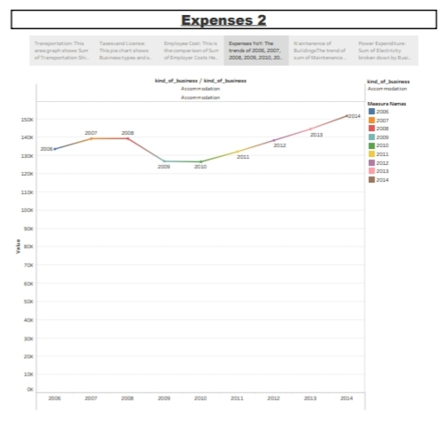

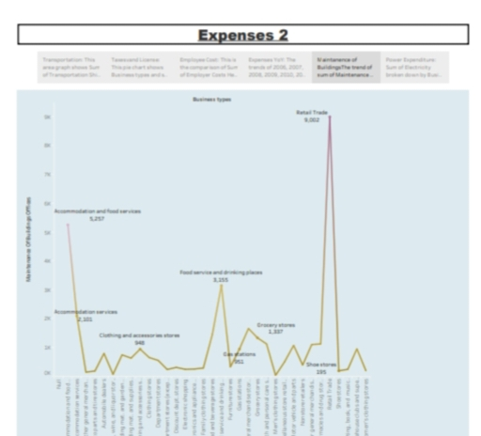

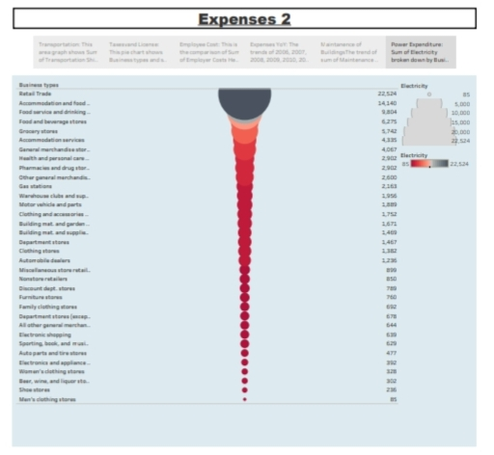

**4.1 ADVANTAGES**

1. **Tax Deductions:** Many business expenses are tax-deductible, which can significantly reduce a company's taxable income. This means that businesses can lower their tax liability and keep more of their earnings.
2. **Cost Management:** Tracking and managing business expenses helps companies maintain control over their costs. This enables businesses to allocate resources efficiently and make informed financial decisions.
3. **Profitability:** By deducting legitimate business expenses from revenue, a business can determine its net profit, which is a critical measure of financial success. Managing expenses effectively can lead to increased profitability.
4. **Investment in Growth:** Businesses can reinvest the money saved from reduced expenses into areas that drive growth, such as expanding product lines, hiring more staff, or investing in research and development.
5. **Competitive Advantage:** Carefully managed expenses can give a business a competitive edge by allowing it to offer products or services at lower prices or with higher quality. This can attract more customers and enhance the company's reputation.
6. **Financial Planning:** Monitoring and categorizing expenses provides valuable data for financial planning and forecasting. It helps businesses create budgets and set realistic financial goals.
7. **Improved Cash Flow:** Controlling expenses can improve a company's cash flow, ensuring that there is enough working capital to cover day-to-day operations and unexpected expenses.
8. **Vendor Negotiations:** Careful expense management can provide leverage in negotiations with suppliers and vendors. It may lead to better terms, discounts, or other cost-saving opportunities.
9. **Compliance and Transparency:** Properly tracking and documenting business expenses helps ensure compliance with tax and regulatory requirements. It also enhances transparency, which can be crucial for building trust with investors, partners, and customers.
10. **Business Decision Making:** Data on expenses can inform strategic decisions. It helps businesses identify areas where cost reductions can be made, areas where investments are needed, and where resources should be allocated.
11. **Employee Satisfaction:** Properly managed business expenses can lead to more predictable and fair compensation and reimbursement for employees, which can improve morale and job satisfaction.
12. **Risk Mitigation:** Monitoring and managing expenses can help businesses identify and address financial risks early, reducing the likelihood of financial crises.

**4.2 DISADVANTAGES**

1. **Tax Deductions:** Many business expenses are tax-deductible, which means that they can reduce the taxable income of the business. This results in lower tax liability and can lead to significant cost savings.
2. **Cost Control:** Keeping track of business expenses allows for better control and management of costs. This is essential for maintaining financial stability and ensuring that the business operates within its budget.
3. **Profitability:** By subtracting legitimate business expenses from revenue, a business can calculate its net profit. Effective expense management can lead to increased profitability, which is a key indicator of financial success.
4. **Financial Planning:** Tracking expenses helps in creating budgets, financial forecasts, and cash flow projections. This enables businesses to make informed financial decisions and plan for the future.
5. **Resource Allocation:** Effective expense management ensures that resources are allocated efficiently. This means that funds and assets are used where they can have the most impact, contributing to the overall success of the business.
6. **Competitive Advantage:** Careful expense management can result in cost savings that allow a business to offer products or services at a lower price or with higher quality. This can attract more customers and provide a competitive edge in the market.
7. **Investment in Growth:** The money saved from reduced expenses can be reinvested in the business to support growth, such as expanding into new markets, launching new products, or increasing marketing efforts.
8. **Cash Flow Improvement:** Effective expense management can lead to improved cash flow, ensuring that the business has enough liquid assets to cover operational expenses and take advantage of growth opportunities.
9. **Vendor Relationships:** Managing expenses effectively can strengthen relationships with suppliers and vendors. This can result in better terms, discounts, or other cost-saving opportunities.
10. **Risk Mitigation:** Tracking and managing expenses helps identify financial risks and allows for proactive measures to mitigate them. This reduces the likelihood of financial crises or unexpected expenses.
11. **Transparency and Accountability:** Proper expense management promotes transparency in financial transactions and increases accountability within the organization. This is important for building trust with investors, partners, and stakeholders.
12. **Employee Satisfaction:** Effective expense management can lead to fair and timely reimbursement for employee expenses, which can boost morale and job satisfaction among the workforce.

**APPLICATION**

1. **Financial Reporting:** Business expenses are a fundamental component of financial statements, such as the income statement (profit and loss statement), where they are deducted from revenues to calculate the net profit. This information is critical for investors, creditors, and other stakeholders in assessing a company's financial performance.
2. **Tax Deductions:** Business expenses are used to reduce taxable income. By deducting legitimate business expenses, companies can lower their tax liability, resulting in potential tax savings. This is a key application for tax planning and compliance.
3. **Budgeting and Financial Planning:** Business expenses are essential for creating and managing budgets. They allow businesses to forecast future expenditures, allocate resources, and set financial goals. Accurate expense data is crucial for making informed financial decisions.
4. **Cost Control:** Monitoring and analyzing business expenses is a vital tool for cost control. It helps businesses identify areas where costs can be reduced or optimized, ultimately improving profitability.
5. **Investment Decisions:** Business expenses can influence investment decisions. Companies allocate funds to areas that promise the highest return on investment, taking into account expenses related to projects, acquisitions, or research and development.
6. **Vendor and Supplier Management:** Effective expense tracking enables businesses to negotiate better terms with suppliers and vendors. It can result in discounts, improved credit terms, and stronger relationships with key partners.
7. **Cash Flow Management:** Understanding and managing expenses is crucial for maintaining a healthy cash flow. This ensures that a business has the necessary funds to meet its financial obligations, pay employees, and invest in growth.
8. **Employee Compensation:** Business expenses include employee-related costs, such as salaries, benefits, and travel expenses. These are essential for fair compensation, payroll management, and attracting and retaining talent.
9. **Compliance and Regulatory Reporting:** Businesses must adhere to tax laws, accounting standards, and other regulations. Properly categorized and documented expenses are critical for compliance and reporting requirements.
10. **Strategic Decision-Making:** Expense data is used in strategic decision-making. Companies analyze expenses to identify areas for improvement, plan cost-cutting initiatives, and allocate resources strategically to achieve long-term goals.
11. **Risk Management:** Managing expenses effectively can help businesses identify financial risks and take measures to mitigate them. This reduces the likelihood of financial crises or unexpected expenses.
12. **Benchmarking:** Businesses compare their expenses to industry standards or competitors to assess their cost competitiveness and identify opportunities for improvement.

**CONCLUSION**

1. **Financial Reporting:** Business expenses are integral to financial statements, such as the income statement, where they are subtracted from revenues to determine a company's net profit. This information is essential for stakeholders, including investors, creditors, and management, to assess the financial health and performance of the business.
2. **Tax Planning:** Business expenses serve as a means to reduce taxable income. By deducting legitimate expenses, businesses can lower their tax liabilities, resulting in potential tax savings. Effective tax planning is crucial to minimize the tax burden while remaining compliant with tax laws.
3. **Cost Control:** Monitoring and managing expenses are essential for controlling costs and optimizing profitability. Businesses analyze their expenses to identify areas where costs can be reduced or streamlined, ultimately improving the bottom line.
4. **Budgeting and Financial Planning:** Business expenses are the foundation of budgeting and financial planning. They help businesses forecast future expenditures, allocate resources efficiently, and set financial goals, which are essential for sound decision-making.
5. **Resource Allocation:** Effective management of expenses enables businesses to allocate resources strategically, ensuring that funds and assets are directed toward areas that can have the most significant impact on the company's success.
6. **Cash Flow Management:** Properly managing expenses is critical for maintaining a healthy cash flow. This ensures that a business has the necessary liquidity to meet its financial obligations, support growth, and navigate financial challenges.
7. **Compliance and Regulatory Reporting:** Businesses must adhere to tax laws, accounting standards, and other regulations. Accurate categorization and documentation of expenses are vital for compliance and reporting requirements, reducing the risk of legal and financial consequences.
8. **Vendor and Supplier Relationships:** Effective expense tracking enhances relationships with suppliers and vendors. It can lead to improved terms, discounts, and mutually beneficial partnerships, contributing to cost savings and operational efficiency.
9. **Employee Compensation:** Business expenses include employee-related costs, such as salaries, benefits, and travel expenses. Proper management of these expenses is crucial for fair compensation, efficient payroll management, and attracting and retaining talent.
10. **Strategic Decision-Making:** Expense data is used in strategic decision-making. It helps companies identify areas for improvement, plan cost-cutting initiatives, and allocate resources strategically to achieve long-term goals and competitiveness.
11. **Risk Management:** Managing expenses effectively helps businesses identify financial risks and proactively mitigate them. This reduces the likelihood of financial crises or unexpected expenses, promoting stability and resilience.
12. **Benchmarking:** Businesses compare their expenses to industry standards and competitors to assess their cost competitiveness and identify opportunities for improvement, which is essential for staying competitive in the marketplace.

**FUTURE SCOPE**

1. **Advanced Expense Management Software:** The adoption of sophisticated expense management software will continue to grow. These tools will incorporate artificial intelligence and machine learning to automate expense tracking, categorization, and reporting, making expense management more efficient and accurate.
2. **Mobile Expense Management:** Mobile apps for expense reporting and approval will become more prevalent. Employees will use smartphones to capture receipts, submit expenses, and managers will approve them on the go.
3. **Digital Payments:** With the rise of digital payment methods, such as mobile wallets and cryptocurrencies, businesses will need to adapt their expense policies to accommodate these forms of payment. This includes tracking and reconciling digital transactions.
4. **Remote Work Expenses:** As remote work and telecommuting become more common, businesses will need to address expenses related to home offices, internet connectivity, and remote work tools. Expense policies will need to be adjusted accordingly.
5. **Sustainability Expenses:** Companies will invest in green technologies and practices to address environmental concerns. This will result in a new category of expenses related to renewable energy, energy-efficient equipment, eco-friendly materials, and sustainability initiatives.
6. **Regulatory Changes:** Tax laws and regulations related to business expenses will continue to evolve. Staying compliant with changing tax codes will be a priority, and businesses will need to adapt their practices accordingly.
7. **Data Security and Privacy:** Protecting sensitive financial and personal data will remain a top concern. As expenses are increasingly managed digitally, businesses will need to invest in cybersecurity and data privacy measures to safeguard expense-related information.
8. **Globalization Challenges:** As businesses expand globally, managing expenses in multiple currencies and complying with international regulations will become more complex. Currency exchange rate fluctuations will need to be managed effectively.
9. **Environmental, Social, and Governance (ESG) Reporting:** Companies will be expected to report on their ESG initiatives, which will introduce a new category of expenses related to sustainability, diversity and inclusion programs, and community engagement efforts.
10. **Real-Time Expense Tracking:** The ability to track expenses in real time will become more widespread. This will provide businesses with immediate insights into their financial health and enable faster decision-making.
11. **Blockchain for Expense Tracking:** The use of blockchain technology for expense tracking and auditing purposes may increase. Blockchain offers transparency, security, and immutable records of transactions, which can enhance expense management.
12. **Customized Expense Policies:** Businesses may develop more flexible and customized expense policies to accommodate different roles and levels within the organization. This allows for a balance between cost control and employee empowerment

**APPENDIX**

1. **Expense Receipts:** Attach scanned or digital copies of receipts and invoices related to the documented expenses. These can serve as evidence of the expenses claimed.
2. **Expense Reports:** Include detailed breakdowns of expenses, categorized by type, date, and purpose. This provides a comprehensive view of the expenses incurred.
3. **Expense Policies:** If relevant, you might include the company's expense policies and guidelines to provide context for how expenses should be handled and reported.
4. **Financial Statements:** Include relevant financial statements, such as income statements and balance sheets, which show the impact of the expenses on the company's financial health.
5. **Tax Documentation:** In the context of tax reporting, you could include tax-related documents such as IRS forms, W-2s, or 1099s that pertain to expenses.
6. **Contracts and Agreements:** Attach any contracts or agreements related to expenses, such as vendor contracts, leasing agreements, or service contracts.
7. **Charts and Graphs:** If you have visual representations of expense data, such as graphs or charts showing expense trends, you can include these in the appendix.
8. **Supporting Documents:** Include any other supporting documents that are relevant to the expenses in question, such as purchase orders, travel itineraries, or legal documentation.
9. **Summary Tables:** Tables summarizing key expense data, such as monthly or annual expense totals by category, can be included for reference.
10. **Citations and References:** If you've referred to specific sources or references in your main document, you can include the full citations or a list of references in the appendix.